**Mr. Visca’s: Calculus (Chpt 3.8)**

**Chpt 3 – Day 14: Inverse Trig Differentiation**

**3.8 Derivatives of Trig Inverses**

First, let's think of inverses, their graphs and slopes at given points f(x) = x2 g(x) =

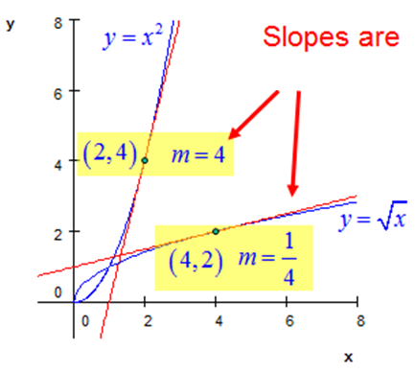

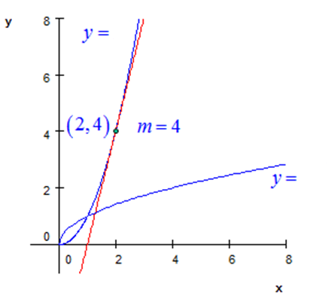

Slopes are:

dy/dx of f(x) @ (2,4) = 4

dy/dx of g(x) @ (4,2) = ¼

So...what do you notice?

**Therefore...**

the derivative of the inverse, is equivalent to ________________________________________________________

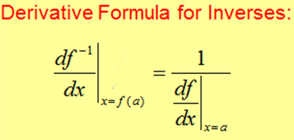



A typical problem using this formula might look like this:

Ex1.

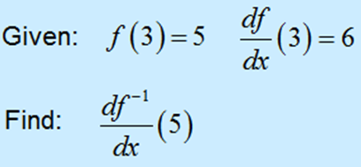

Ex2. If S is the inverse function of f, if f(x) = x3 + x, find S’(2)

***QUESTION***: What if there is more than one y value when you try to get inverse value? (in other words, what happens if function is not 1-1, fails horizontal line test)?

**________________________________________________________**

**Your Trig Inverse Derivatives!!! FYI…**

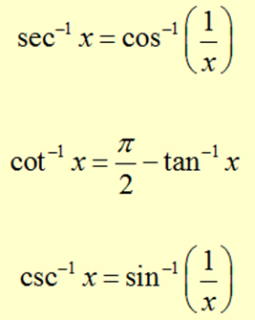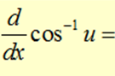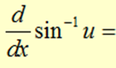

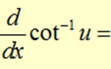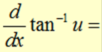

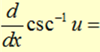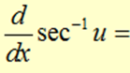

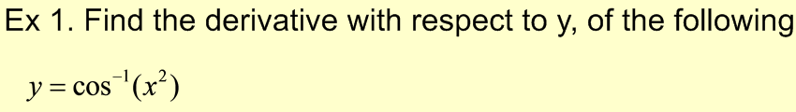

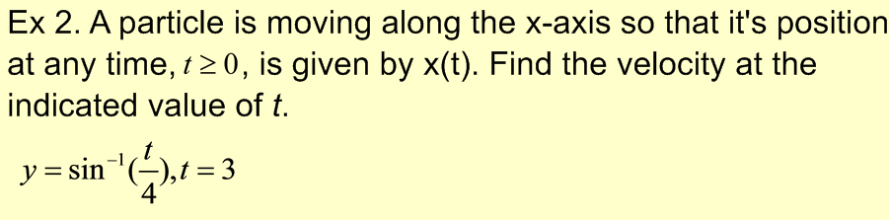

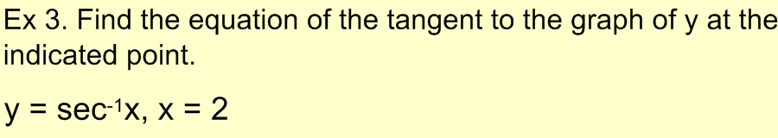

***Sec 3.8***

***Page 170 (2-8 even, 12, 16, 20, 26, 27)***